Truffles

Hýdna (truffles) originate spontaneously from the earth especially in sandy places. Teofrasto says, "The truffle is all that grows under the ground." It's still:
"The generation and growth of these underground plants are simultaneous, as in the case of truffles and what grows around Cirene, which they call mìsy. This seems to be very pleasing to have the smell of the flesh, like the oitòn that It grows in Thrace, and is referred to as a characteristic: it is said that they grow when autumn rains occur. They live for more than a year, but reproduce annually: they have full maturation and utilization in the spring, but some assume that they originate in So on the Militian coast it is said that they snack only after, after torrential rains, the seed is brought down from Tìare. They grow especially on the coasts and where the soil is sandy

​
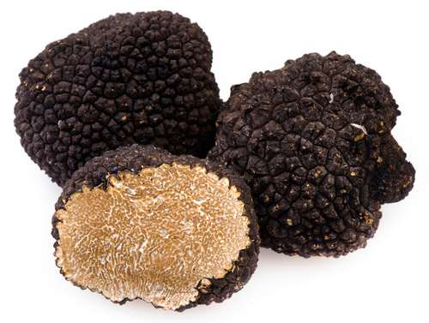
Truffles
Ὕδρον

